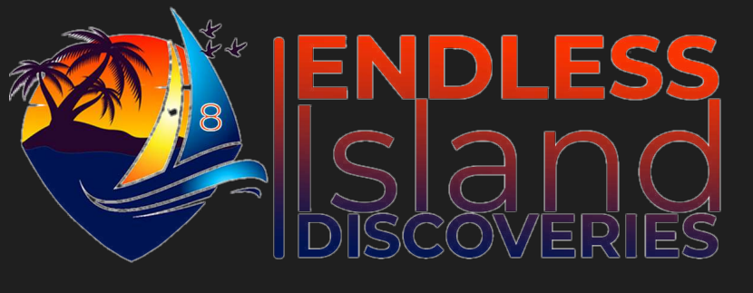

THANK YOU FOR YOUR INTEREST!!!!!
THIS TOUR IS CURRENTLY UNAVAILABLE AT THE MOMENT!!!!
PLEASE FOLLOW AS WE WILL UPDATE YOU WHEN THIS TOUR WILL BE AVAILABLE FOR SERVICE.
DO BROWSE OUR SITE FOR MORE INTERESTING EXCURSIONS YOU MAY LOVE!

THANK YOU FOR CHOOSING ENDLESS ISLAND DISCOVERIES
WE APPRECIATE YOU!

